Minutes of Somerford Keynes Parish Council Meeting
Village Hall, 9th October 2023

Present: Cllr G. Valentine (GV), Cllr M. Keegan (MK), Cllr A.Clark (AC), Cllr H. Collins (HC),
Cllr M.H-Oldland (MH-O), Cllr N. Hunt (NH)

Also present: Clerk K. Holdsworth (KH), CDC Cllr M.McKeown (MM), Mike Wilding (MW) Village Lake Committee Chair and six members of the public.

1.Election of Officers
AC has agreed to be Chair for the coming year, proposed by MK and seconded by GV.
Notice of vacancies for new Councillors ends on 11th October.

2.Apologies
GCC Cllr L. Spivey (LS)

3.Declaration of Interest
GV and HC (LME)

4.Public Session
There were no matters raised in the public session.

5.Approval of Minutes of the meeting held on 24th July 2023
Proposed GV, seconded MK.

6.Report from County Cllr L. Spivey
Cllr Spivey’s report is in appendix one.

7.Report from District Cllr M. McKeown
Of most interest to parishioners will be the refusal of the planning application on Land to the South East Of Ashland House. The PC expressed its thanks for the support our CDC representatives have provided.

The first installation of the Thames Head Solar Scheme is complete, if anyone is interested in this programme they can contact Mike.

8. Village Lake
MW’s report can be found in appendix two.
The request for additional funding will be assessed as part the wider PC financial review as described in 10.1.
It was agreed that MW only need to report to the PC on a quarterly basis, the next being January 2024.

9. Completed Actions From Previous Meeting

9.1 AC to write to Cllr L Spivey to reinforce the efforts she has already made around Spratsgate Lane junction with Ewen to South Cerney road.
PC will continue to monitor
9.2 MK and HC to draft a letter to the Planning Department ref planning application 23/0229/FUL asking what are the visitor number/capacity reasons that that make this necessary and for clarification of the waste details.
9.3 GV to agree a date for a PC meeting convenient for Rob Squizzoni to attend.
Rob will attend next month’s PC meeting.
9.4 KH to look into the feasibility of the PC moving to online banking.
This can be done and will pursued in the new year.

10. Ongoing and New Actions

10.1 Finance
GV reported initial findings and is working with KH on next level of detail.
Action: GV to summarise income, committed and run rate expenditure to understand the gap. Also to identify CIL monies and their use by dates.
Agreed that PC should also come up with a framework to assess merits of different spend options.
10.2 Community Speed Camera
Still no confirmed install date from Gloucestershire Constabulary
Action: MHO to provide updates.
10.3 Cullimore Flood Prevention Works
Ditches are dug but there are no pipes in place.
Action: MK to raise with Jason Betty at GCC.
10.4 Cotswold Country Park & Beach Noise
No response to letters sent by MK.
Action: MK to contact Ben Wellbourne at Cotswold Lakes Trust.
10.5 Community Survey
These actions come out of feedback from the survey.
10.5.1 MHO to engage Thames Water on the topic of mains sewerage
10.5.2 MHO to engage Gloucestershire Highways on the topic of extending footpaths, most notably to Neigh Bridge
10.5.3 NH to pursue discussion on ‘missing link’ cycle path from SK to Ashton Keynes crossroads in local groups. These have already begun.
10.5.4 AC to draft note on survey for parishioners, including how results will guide the actions of the PC going forwards.
10.5.5 MHO to draft ‘legacy statement’ as guidance as to how CIL funding might be invested.
10.6 Flooding
HC has engaged parishioners with deep knowledge and a neighbouring PC to understand their approach.
Action: HC to define what we want to and can achieve here. For example, might be documenting water courses to provide a guide as to what should proactively be checked periodically.
10.7 Lake 32 Access
Request made by parishioner to see if reduced membership rates could be offered to local residents.
Action: AC to ask the question.
10.8 Training
Action: Councillors and Clerk to identify any training they may wish to undertake.
10.9 Contact List
Agreed that a central list held by the Clerk would be useful for now and to subsequently pass on.
Action: Councillors (or parishioners) to provide details.
10.10 Lower Mill Twelve Month Occupancy
Action: MM to confirm CDC policy on this.

11. Other Matters

11.1 Rural England Prosperity Fund
New funding is available with a deadline for submissions of November 10th. In the last round a number of local organisations made submissions, MHO is willing to assist anyone who wishes to make one this time around.
Action: Anyone making a submission or requiring further information can contact Mark via skpcclerk@gmail.com
11.2 Councillor Focus Areas
It was agreed that each councillor should lead on a specific topic as follows;
AC – Chair and local landowners
GV – Finance
HC – Flooding
MK – Planning
MHO – Highways
NH – Local Business and Local Organisation
TBC – Environment
11.3 Correspondence
Two parishioners have written against any move for yellow lines around Neigh Bridge on the basis that it will simply push parking further into the village (as happens at the eastern end). It would also create a level of urbanisation which was a something many respondents to the community survey wish to avoid.
The PC are supportive of these views.
11.4 Spine Road/Ashton Keynes Junction
Was highlighted by parishioners in recent correspondence on historic accidents. KH has engaged with Ashton Keynes PC who have highlighted it to Wiltshire CC.

12. Planning Items

12.1 19/04270/FUL
Full Application for Erection of 4 dwellings, new road access, footpath, and associated landscaping including public open space and an attenuation/soakaway pond
Land To The South East Of Ashland House Somerford Keynes Gloucestershire.
Additional details added for information only.
PLANNING PERMISSION REFUSED

12.2 23/02209/FUL
Full Application for Erection of bathroom/changing facility block at Lake 32 Spratsgate Lane Somerford Keynes Gloucestershire.
Objection submitted on 25th September.

12.3 23/02761/FUL
Full Application for Installation of 15 no. PV panels at Lacewing Villa 61 Howells Mere Lower Mill Lane Somerford Keynes Cirencester
No Objection

12.4 21/02705/FUL
Full Application for Variation of Condition 2 (Approved drawings) and Condition 3
(Occupancy) of application 21/02705/FUL The erection of 17 detached holiday units within Minety Lake South West (also referred to as Barberry Lake); the erection of three detached holiday units within Lakeshore Reserve West; amendments to the water's edge of Minety Lake South West; ancillary buildings, provision for new landscaping and revised ecological areas, visitor parking and vehicular access at Minety Lake South West Lower Mill Estate Somerford Keynes Gloucestershire) to amend the permitted unit, to add a boat store and to change the occupancy restriction on plot 70 at 70 Minety Lake Lower Mill Estate Somerford Keynes Gloucestershire
No Objection

13. Financial Matters

Income
Rent on Parish Field £1575 received.
Precept Payment £1000 received.

Outgoings
Clerks Salary £636.50
Printer Ink £36.60

The meeting closed at 9.25 pm

Date of next meeting: Monday 13th November 2023 at 7.30 pm
Appendix One – Report from County Cllr L Spivey

Councillor Lisa Spivey
Gloucestershire County Council
Report October 2023

- Boundary Review
Following consultation on proposals earlier in the year to increase the number of county councillors from 53 to 55, The Local Government Boundary Commission for England has now published detailed proposals for new division boundaries.
The changes are being proposed to address the fact that growth and change in the local population means some divisions are now much bigger than others. The review will adjust the boundaries of the divisions to which councillors are elected in order to make sure that, from the next election (May 2025), every councillor represents a similar number of people.
The Commission is proposing changes to the boundaries of 39 divisions, with 14 staying the same. They are also proposing the creation of two new divisions: one in Stroud and one in Tewkesbury. The Commission is proposing that each division continue to be represented by one councillor.
The Local Government Boundary Commission now wants to hear what residents and local organisations think about their proposals.
The Commission has a dedicated section on its website where people can see the detail of the proposals and comment on the names of divisions and their boundaries: www.lgbce.org.uk/all-reviews/gloucestershire
Consultation on the proposals runs until 11 December 2023.
- Build Back Better Fund
I still have funds available for community projects and each councillor has been awarded a top-up of £10,000. Funds have to be spent by January 2025, so please do get in touch if you have a project that is ready to go.
- Flood Forum
At the last Full Council meeting, the council unanimously supported a motion to look at flood prevention and hold a summit to ensure that the most at risk communities have flood risk management programmes in place to minimise potential flooding.
- Footpath maintenance – weeds
In response to a member question regarding footpath maintenance, the Cabinet member for Highways, Cllr Dom Morris encouraged communities to tackle weeds and grass growing in local footpaths themselves. Cllr Morris said that “This does appear to be the perfect scenario where member led community self help could free up our pressurised highways teams.”
- Grit bins
Thanks to those who responded about new grit bins in your parish. All applications are being assessed and new bins will be allocated where there is most need.
- New Bus Funding
The Council has recently been awarded a further £4.4million to go towards improving bus services in the County.
I am delighted that part of this has been allocated to setting up a “Robin” service in the South Cotswolds. The Robin is an on demand rural minibus service which has been operating successfully in the Forest of Dean and (somewhat less successfully) in the North Cotswolds for the last year. I have asked to be involved in designing how that works as this is something I think could be very useful in this area. Please let me know if you have any thoughts on this.

Upcoming meetings
Wed 8th November – Full council – please let me know if you have any questions you would like to ask.

Appendix Two – Village Lake Report from Mike Wilding

Somerford Keynes Village Lake
REPORT TO SKPC for 9th October 2023 MEETING

1 COMMITTEE MEMBERS: The Lake Management Committee consists of 5 members: Mike Wilding (Chairman), Lisa Willis, Nick Cartwright, Jane Hayman & Graham Valentine (SKPC Councillor). This arrangement complies with our insurer’s (ZURICH) requirements for volunteer workers and public liability, as there is a public footpath around the lake.

2. MONTHLY INSPECTIONS: September inspection was carried out by Nick Cartwright
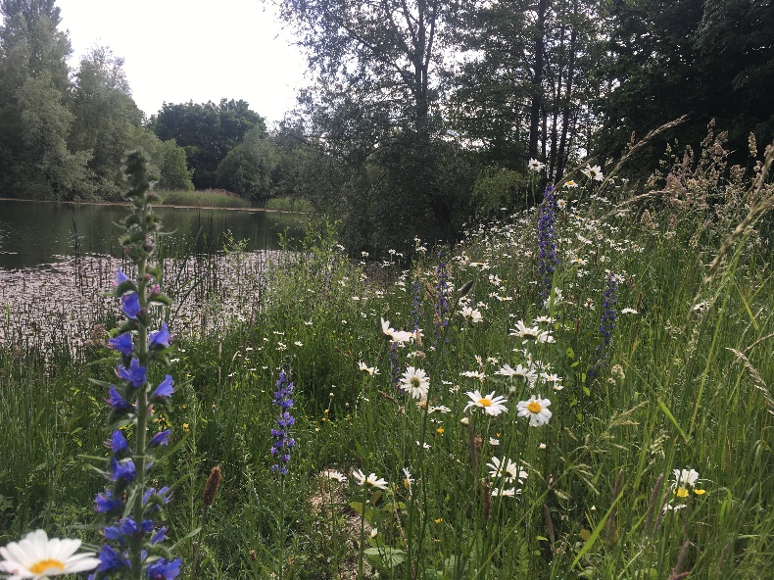
3. VOLUNTEERS MORNINGS: Volunteer mornings are planned for 5th and 12th October primarily to trim shrubs and branches overhanging the path and carry out the wildflower areas’ autumn maintenance follow on work, after Contractor’s visits. Flyer has been circulated.

4. CONTRACTOR WORK: Cotswold Estates & Gardens (1 man) were at the Lake for a couple of hours on 20 September to carry out the “hay cut” with their power brush cutter on both the large wildflower areas on the N side and the 4 smaller lake vista areas on the S (Spine Rd) side. They will return to rake into heaps, the N side large areas, on Tuesday 10 October.
mjw 2 October 23

