Minutes of Somerford Keynes Annual Council Meeting
Village Hall, 11th May 2026

Present: Cllr A. Clark (AC), Cllr H.Collins (HC), Cllr M. Keegan (MK), Cllr G.Valentine (GV), Cllr J Whitwell (JW),

Also present: Clerk K.Holdsworth (KH), Clerk from 15/5 S. Pawlowska (SP), CDC Cllr M.McKeown (MM) and one member of the public.

1. Apologies
Cllr N.Hunt (NH), Cllr M.H-Oldland (MHO)

2. Declaration of Interest
None

3. Election of Officers
AC and NH re-elected as chair and deputy chair respectively.

4. Public Session
Nothing raised.

5. Approval of Minutes of 9th March 2026 Meeting
Proposed JW, seconded AC

6. Report from GCC Cllr Lisa Spivey (LS)
CC LS’s annual report is in Appendix One.

7. Report from District Cllr M.McKeown
Cllr MM’s report is in Appendix Two.
The PC thanked Mike for all his hard work on the Anaerobic Digester objection.

8. Report from Mike Wilding
Mike Wilding’s Village Lake report is in Appendix Three.

9. General Matters

9.1 Road Signs
KH has written to GCC Highways and CDC regarding this. The Mill Lane sign has been repaired.

9.2 Kemble Mill & Water Lane Paths
JW has investigated. Kemble Mill is unoccupied now so there is no one to speak to about the overgrown footpath (which would be the owner’s responsibility). Therefore it would be helpful if any parishioners walking that way could take their secateurs and have a go at cutting back themselves! JW has led the way on this.
Regarding Water Lane, cutting back will need to wait until the bird nesting season has finished. Proposal is to publish a date and invite parishioners to come along and help tidy it

9.3 Spring Flowers
AC had an action to talk to Bewley Homes about this. Dialogue with them has been focussed on the Anaerobic Digester, will revisit now the consultation date for that has passed.

9.4 Neigh Bridge Kiosk
HC has chased the Environment Agency as this work has still not been undertaken. We await their statement that budget is available this year to do the work. Which will be the third year they have promised….

9.5 Thames Water
MK stated that Shorncote residents are noticing much more smell from the Cirencester Sewage Treatment Plant.
Action: HC to email Lisa Spivey (as she recently ran a sewage summit) and request a visit to the treatment plant.

9.6 AGM
Planning of speakers, refreshments and logistics are all finalised. Thanks to KH for her work on this, we hope for a good turnout.

10. Community Infrastructure Levy

In this section we cover a mix of projects approved and in progress along with new suggestions.

10.1 AV Equipment in Village Hall
In a test to prepare for upcoming meetings the current AV equipment in the Village Hall appeared not to work. As it will be needed for the AGM, the parish council voted to purchase its own new equipment.

10.2 Swings at Neigh Bridge
Still awaiting a response from the Cotswold Lakes Trust on confirmation of final costs and timings.

10.3 Coffee Machine in Village Hall
A parishioner suggested the purchase of a bean to cup coffee machine that they (and others) would use to make and sell quality coffee at events. It could also be used by general hall users if they wish (users would need to supply their own beans). The PC voted to approve.
Actions: AC to confirm that Village Hall Committee are happy to approve having this in the kitchen, SP to write to the parishioner who made the proposal asking them to select a machine costing up to £1k which the PC will purchase.

10.4 Bleed Packs
These have been ordered and paid for, we are awaiting delivery and Marcus Gibbons has kindly offered to install them when they arrive.

10.5 Shorncote Parish Church
Coping stones have fallen off the church; they have been taken away and the area has been covered with tarpaulin and secured for safety. The PC have approved spend to pay for repairs but are awaiting more quotes from the Church Conservation Trust to ensure best value is achieved.

10.6 Table Tennis Table
The PC have voted to fund a table tennis table for the village hall car park (or in the village hall). This has been passed on to the Village Hall Committee to make a final decision. They are meeting in June.

10.7 Primary School Projects
The offer to help local primary schools has been well received with projects flagged at Ashton Keynes (firepit), Oakey (outdoor learning space) and South Cerney (new lunch chairs and table). The PC are very pleased to support these.

11. Finance & Governance

KH & SP reclaimed the VAT on 2025/2026 spend and have received a refund of £4083.56,
More CIL Money received (£5321.59) plus first part of 2026/27 precept.
These will show in May’s accounts.
KH applied for a transfer of £10,000 of CIL money from the high interest into the current account to cover anticipated spend on approved CIL projects.

12. Planning

TOWN AND COUNTRY PLANNING ACT 1990 APPEAL UNDER S78 AGAINST REFUSAL OF A HOUSEHOLDER APPLICATION
Site Address: Peregrine House 19 Clearwater Village Lower Mill Estate Somerford Keynes Cirencester Gloucestershire GL7 6FJ
Description of development: Erection of three-storey rear extension and single-storey front extension with associated works
Application Reference: 25/04037/FUL
Appellant’s name: Mr Mike Yiannis
Appeal Reference: 6007748
Appeal start date: 9 April 2026
No objection

26/01226/FUL
Full Application for Installation of Air Source Heat Pump with associated screening
(retrospective) at 9 Minety Lake Lower Mill Estate Somerford Keynes Cirencester
Gloucestershire
No Objection

PL/2023/03359 – Anaerobic Digester
As per previous communication, Wiltshire Panning recommended approval of this.
It went to their Strategic Planning Committee on April 13th where the decision was deferred.
It will come back to the Strategic Planning Committee for a decision, likely date is June 16th.

In the meantime a PC Subcommittee was formed and a group of parishioners have worked extremely hard to build a case against it and raise awareness.
The result is the crafting of a new objection based on the impact on leisure, tourism and the local economy which has been submitted.
The awareness raised has also resulted in over 1200 more objections being lodged in three weeks; twice as many as were recorded in past three years.

The PC thanks those on the subcommittee very much for their tireless work here.

26/01387/FUL
Full Application for Variation of condition 8 (occupancy break) of permission 25/00422/FUL
(Variation of condition 20 (specific time/occupation) to permission 04/03278/FUL - Replacement of permitted facilities
building with 3 holiday units)
at 2 The Somerford Lodges Lower Mill Estate Somerford Keynes Cirencester
Gloucestershire
No objection

13. April 2026 Income and Expenditure

Income £200.19 Interest Earned April 2026
£4725.00 First precept payment
Total Income £ 4925.19

Expenditure
April 2026 £29.25 Refreshments for litter pick
£1074.45 Clerk’s salary (Jan/Feb/March)

Total Expenditure £1103.70

Village Lake £358.74 various invoices
VL Total Expenditure £358.74

CIL Expenditure £0.00

Total CIL Spend £0.00

Transfers £None

Petty Cash Expenditure £None

14. Correspondance

14.1 Field Farm
The owner of Field Farm replied to a request about activities there. He made an offer to potentially host a community shop should anyone he interested in running one. If you are, then let us know and we will put you in touch.

14.2 Community Event
The PC is pleased that a parishioner has come forward with an offer (with a group of others) to potentially organise a community event.
Action: SP to write to them offering a budget of £1k. Prior to issuing the money the PC would need to see a plan for the event which would need to offer something for as many people in the community as possible.

14.3 Anaerobic Digester
See point 12.

15. Any Other Business

15.1 The Ashlands field has been purchased by a parishioner and is now a private field.

15.2 There is a community (not PC) WhatsApp group. If you are not on it and would like to be email clerk@somerfordkeynes-pc.gov.uk with your mobile number and that can be passed to the administrator.

Meeting closed at 9pm

Date of next meeting is Monday 8th June 2026

Appendix 1
CC Lisa Spivey’s report

Cllr Lisa Spivey
South Cerney Division
ANNUAL REPORT
The Liberal Democrats campaigned successfully in May 2025, winning 27 of the 55 seats at Gloucestershire County Council and formed a minority administration. We set to work immediately to implement the key pledges in our manifesto and you can find here an update on the progress we have made so far. We still have lots to do and are excited about carrying on with this work over the next year.
Local Government Reorganisation (LGR) and Devolution
LGR has been an enormous focus for the Council over the last year. We successfully collaborated with the district, borough and city councils and jointly prepared a business case for the single unitary (1UA) and the 2 unitary East/West split (2UA) options. Gloucester City Council separately worked on the 2 unitary Greater Gloucester model. All 3 options were submitted to government in November 2025 and government carried out a consultation in Spring 2026.
We expect a final decision on which option is preferred from government in Summer 2027.
All 7 councils continue to work together to ensure that the transition to unitary authority(ies) is as smooth as possible. Together we have set up a programme board with numerous workstreams covering people, digital, governance, property and more. This will help ensure the county is ready regardless of which option Government selects.
We have expressed our interest in joining the West of England combined authority (WECA). This is the best fit for Gloucestershire as it has the strongest score across all assessment criteria including economic alignment and existing partnerships.

Finance, Assets & Transformation
We have carefully analysed all council spending to identify where savings and efficiencies can be made in order to open more funding for the areas that matter most to our residents.
We identified over £32 million in savings which were missed by the previous Conservative administration, allowing us to pass an ambitious budget focused on investment in areas that matter most such as highways, education and care. This is despite the Governments poorly named ‘fair’ funding review which hugely reduced the funding we get from Government.
We continued our commitment to a fair, open council through our Commercial Strategy and our ambitious Stronger Future Strategy. This overhauls GCC’s commercial operations, procurement and income generation to ensure we are business like, embedding data and AI to improve efficiency and redesigning the organisational structure ahead of LGR.
We are working hard to transform the way this council works and ensure we are getting the most out of each and every pound spent and deliver better services.
Highways
The adverse weather this year has led to an increase in potholes and decrease in road quality across the entire country. However, we remain committed to tackling these issues and improving conditions across the county.
We are undertook a highways peer review to ensure the department is working as efficiently and effectively as possible and will be making any changes that are deemed necessary.

We committed an extra £15 million into highways in our budget, the biggest county cash boost for generations.
This will allow us to get as many highways’ teams out as possible, battling potholes and resurfacing roads.
We have fixed a whopping 47,000 potholes since taking power and are resurfacing a further 55 roads this spring alone with further resurfacing schemes over the financial year still to be announced.
We launched our “Clean Sweep” initiative last summer targeting the left over signs and equipment littering verges. It also gets contractors to make sure signage faces the right way, clear weeds from gullies and sweep up debris while they’re out and about.
Sustainable Transport & Strategic Highways
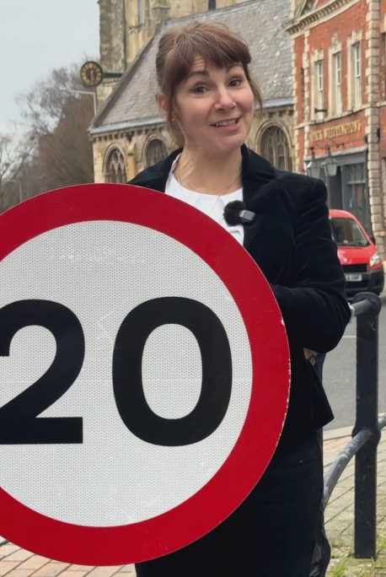
On taking control of the council, we made improving road safety a key priority. Part of the suite of measures aimed at making this change has been the introduction of 20mph zones and lower speed limits where it is supported by communities.
Consultation on the first schemes has begun and we look forward to rolling out the scheme across the county over the next year.
We have also continued with construction of the cycle spine connecting Tewkesbury, Gloucester and cheltenham. This provides a safer space for cyclists to use, promoting greener, healthier living and putting infrastructure first.
We have facilitated the launch of two large electric bus fleets by working with both Stagecoach and Pulham’s and although these 2 projects don’t directly affect the South Cerney division, they are indicators of the commitment in the county to improve public transport.
We have expanded the reach of the Robin, our on-demand bus service, to further rural areas.
We have created a map of the entire county’s bus routes to make it easier for residents to plan journeys by public transport.
Business, Economic Development, Planning and Infrastructure
We launched our new Digital Strategy with a focus on innovation, inclusion and infrastructure.
- We are working with infrastructure providers to ensure that we have best-in-class mobile and broadband infrastructure reaching all corners of our county – including here in the South Cerney division!
- We are ensuring that all our residents have access to technology and are confident using it.
- And are bringing together leading digital thinkers in a Digital Innovation Advisory Board.
We are driving the rollout of Business Improvement Districts across the county.
We set up a multi-agency working group for the Forest Of Dean to tackle deprivation.
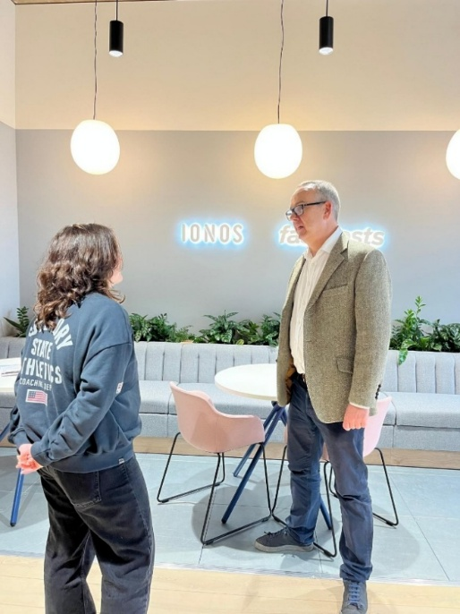
We lobbied hard to receive additional funding for the M5 Junction 10 improvements scheme. This is now underway and we are incredibly excited about the infrastructure upgrade that will unlock homes, jobs and investment for our county.
We launched our Gloucestershire Business Board to bridge the gap between leading local businesses and the Council. This enables us to fully understand their needs and gives them a clear role in holding us to account, while we work hand in hand to deliver our Economic Growth Plan.
We have also launched a full review into how we work with our prominent farming and agriculture industry, alongside a Made in Gloucestershire review. This will help us optimise our support for farmers and small food and drink producers.
We are working hard to support existing local businesses and encourage investment into the county, with a focus not just on the towns, but our expansive rural communities as well.

Children’s Services & Education
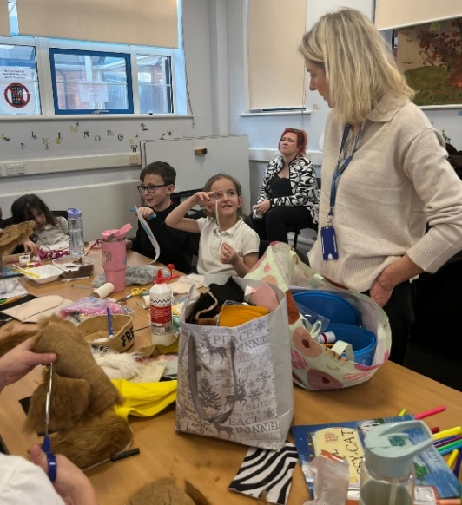
After 16 years of poor Ofsted ratings under the previous Tory administration, Children’s Services is now rated as ‘Good with Outstanding features.’ A huge achievement in such a short time in administration.
We launched our Family Hubs network - welcoming, one-stop spaces designed to bring families together and make sure no one ever feels they have to navigate parenthood alone.
Providing everything from advice, fun activities, support, or simply a friendly face who listens, our Family Hubs are here for our communities and children, every step of the way.
We’ve extended the Holiday Activities and Food (HAF) programme for another three years. This provides holiday activities and healthy meals as well as support for families, including advice on food, health, and wellbeing.
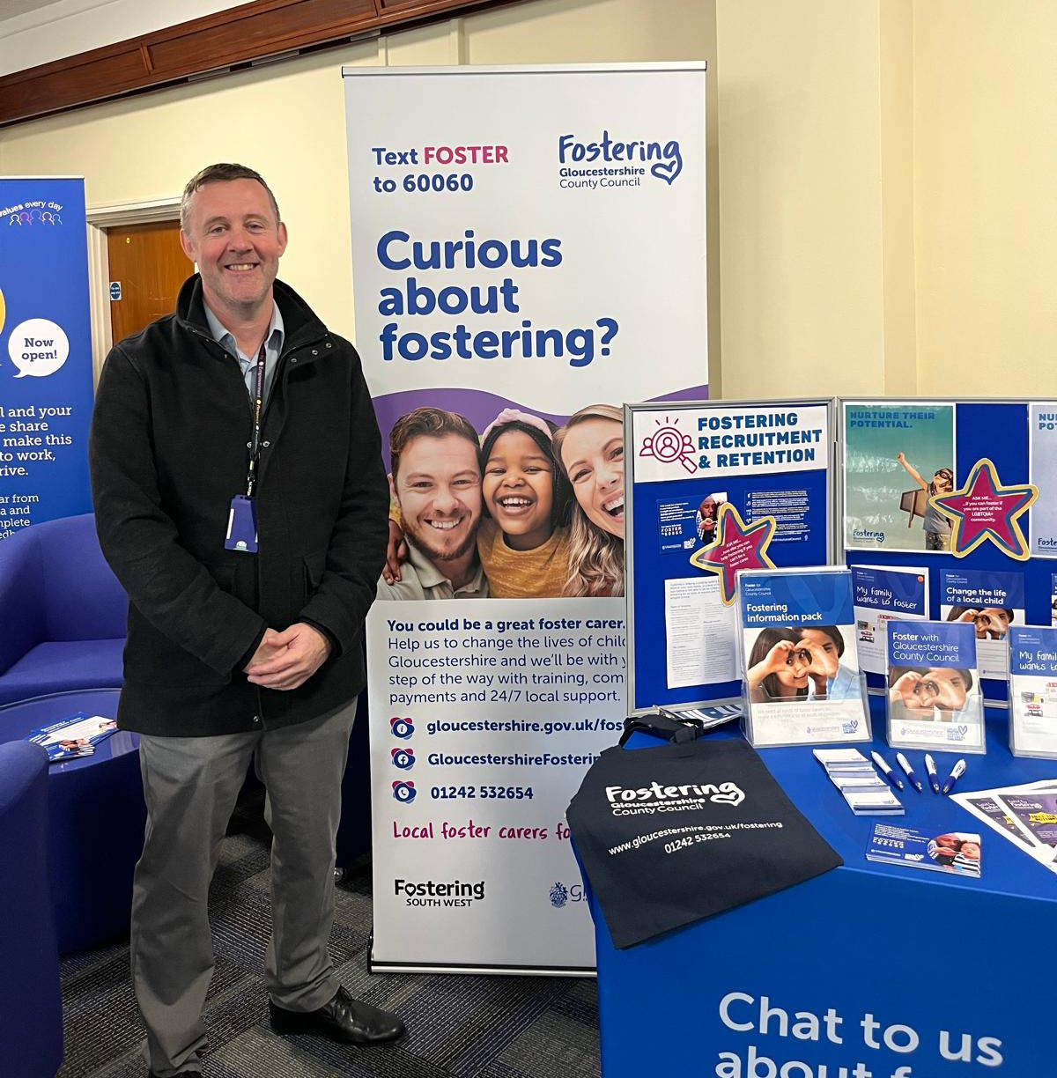
We extended this so its accessible to ALL families not just those on low income.We are in the process of creating 3 new special schools, so that children with complex needs can access the education they deserve.
We welcomed the SEND White Paper and are currently reviewing how it will impact us, ensuring we can continue to provide the best possible support for ALL children of this county.

Adults' Support & Independence
We inherited an Adult social care service rated 'requires improvement' from the previous administration and have been working tirelessly to transform this.
We want all vulnerable adults to live in a place they call home, as independently as possible, for as long as possible, living “gloriously ordinary” lives. To achieve this, we are investing in technology that helps to keep people safe at home and building three brand new care homes across the county so that people can stay close to their loved ones if they do need residential care. We are welcoming vital staff members, including Occupational Therapists and mental health social workers, back into our team so that we can work together to help people maintain or regain their independence.
Later this year, we will launch our brand-new Gloucestershire Social Care Academy, a virtual space providing easy access to accredited training and qualifications for all carers, paid and unpaid. Caring is an incredibly demanding role, and we want all carers in Gloucestershire to know that they are valued and appreciated, supported to give the best possible care to the people they look after, and able to get help themselves when they need it.

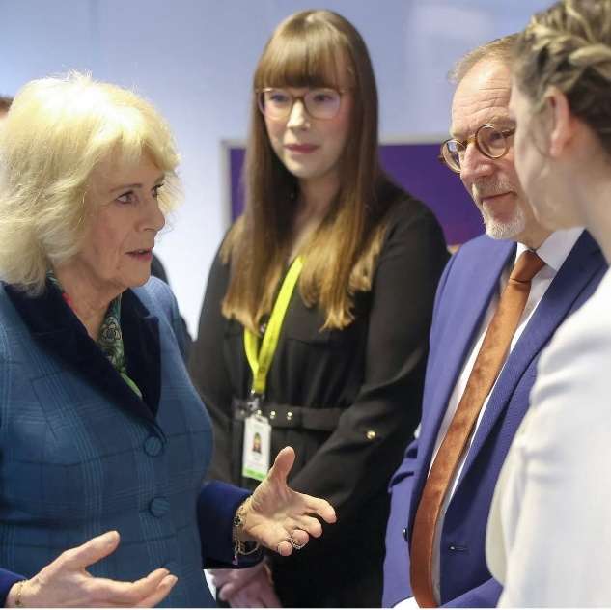
Public Health, Communities & Fire
We launched our new Domestic Abuse Strategy. We are investing in prevention, protection, and partnership to ensure every resident can live free from fear and harm. The launch of this was honoured by a visit from Her Majesty The Queen.
We are investing in our Fire and Rescue Service, ensuring the best team and equipment is available for our communities in times of need, including investing in ten new fire engines.

We are updating our libraries, making them modern, inclusive and accessible. We worked with the University of Gloucestershire to open the new Gloucester Library with a host of exciting features including a dedicated, self-contained Lab space, ideal for workshops, creative sessions and community events.
We launched our Grassroots Neighbourhood Fund, providing £1.1 million in community funding for initiatives that seek to make a positive impact on health and wellbeing and our local communities.
I still have some of my allocation left, so please get in touch if you have a project you’d like support with.
Nature, Climate & Waste Reduction
We launched our Local Nature Recovery Strategy (LNRS), a county-wide spatial plan designed to guide nature recovery, identifying priority habitats, and supporting biodiversity enhancement across Gloucestershire.
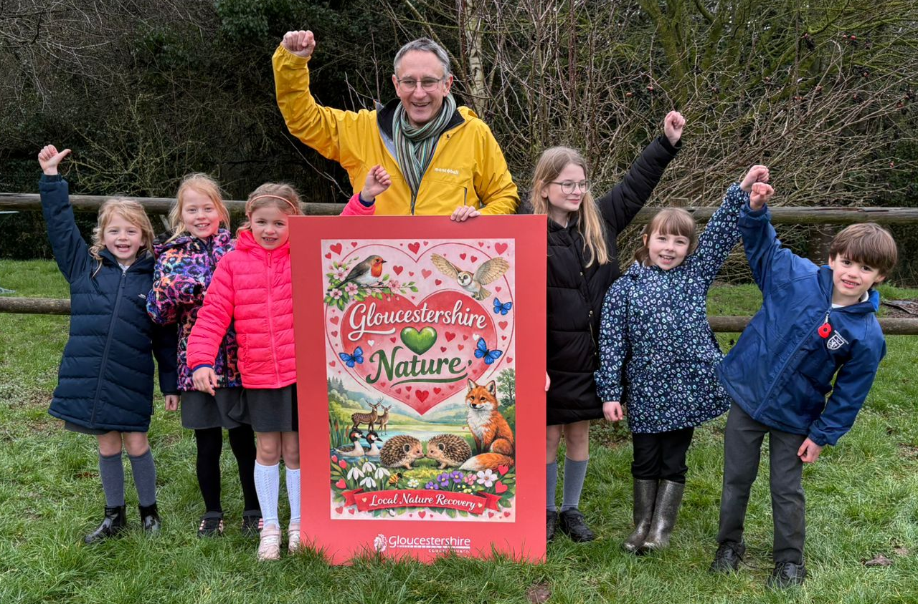
We’ve committed £3.9m over the next four years to upgrade three more of our household recycling centres, making them safer, more efficient and lower carbon.
Launched a £100,000 fund for natural flood management schemes in local communities and are working the Environment Agency and regional partners to support natural flood management at landscape scale across the county
We’ve relaunched a £100,000 fund for local climate action projects and committed to work with our suppliers and contractors to properly measure and tackle the 73% of our carbon footprint that comes from bought-in goods and services
We’ve championed community composting, the reduction of food waste and the re-use and recycling of everything from electrical equipment to coffee pods while converting our waste haulage fleet to run on sustainable vegetable oil.
Finally, we’ve just published our sixth annual climate change report, and the results show our emissions are continuing to fall, a clear sign of our ongoing commitment to Net Zero.

This is just an overview of the many, many initiatives, projects and ways of working we have initiated this last year. There is much more going on at the council, so if you have any specific areas you would like more information on, please get in touch.

Best wishes,

Lisa

Cllr Lisa Spivey
Tel: 01285 653405
Lisa.spivey@gloucestershire.gov.uk

Appendix Two
Report from Cllr Mike McKeown

Kemble Ward Monthly Report - May 2026
Prepared by: Mike McKeown
Councillor for the Kemble Ward
Cabinet Member for Climate Change and Digital Services
Cotswold District Council (CDC)
mike.mckeown@cotswold.gov.uk
07785 362 573
Here is my latest monthly update covering ward matters first, followed by wider district work in
my role as Cabinet Member for Climate Change and Digital Services.
1. Ward matters and local casework
Ashton Keynes anaerobic digester planning application
The proposed anaerobic digestion (AD) facility at Land West of Ashton Road, Ashton Keynes,
remains the most significant local planning matter I am currently working on with residents,
parish councils, local businesses and other elected representatives.
Although the application is being determined by Wiltshire Council, the potential impacts are
clearly cross-boundary. The site sits close to the Cotswold Water Park and the Gloucestershire
border, with possible implications for Somerford Keynes, South Cerney, the wider Water Park
visitor economy, local roads, groundwater, odour, noise and the setting of nearby communities.
I have been working with others to scrutinise the application in detail and to prepare a
consolidated representation for Wiltshire Council's Strategic Planning Committee. The current
deadline for comments is 13 May 2026, with the committee date listed as 16 June 2026.
The main concerns being raised include:
• the scale of the proposal, including around 91,000 tonnes of feedstock per year and up to
160 HGV and tractor movements per day at peak harvest periods;
• the location close to the Cotswold Water Park SSSI, within a Source Protection Zone, and in
an area with shallow groundwater and sensitive water bodies;
• traffic and highway safety on rural and recreational routes used by residents, visitors,
cyclists, walkers and local businesses;
• odour, noise, lighting and amenity impacts on nearby villages, homes, schools and holiday
accommodation;
• whether the claimed climate benefits are robust, particularly given the proposed use of
dedicated energy crops and the need to transport feedstock, digestate, biomethane and
carbon dioxide;
• the long-term enforcement challenge if permission were granted, particularly where impacts
such as odour and traffic are difficult to monitor and control after the event.
I support renewable energy and low-carbon infrastructure where it is genuinely sustainable and
appropriately located. My concern here is that this proposal appears to be in the wrong location
for an industrial-scale AD facility, with too much unresolved risk for surrounding communities
and the Water Park.
I will continue to work with parish councils, residents and technical objectors as the application
moves towards committee, and I will keep local communities updated as the timetable develops.
View the application on the link here.
Planning and enforcement updates
I have continued to follow up ward planning and enforcement matters raised by residents and
parish councils. As noted in previous reports, enforcement processes can take time, and the
council will usually seek a negotiated resolution before formal notices are considered.
Residents wishing to report a suspected breach of planning regulations should do so directly
through the council's planning enforcement reporting page:
https://www.cotswold.gov.uk/planning-and-building/planning-permission/report-breach-ofplanning-
regulations/
Kemble to Cirencester Cycle Path
Following the positive progress reported last month, work continues on the proposed Kemble to
Cirencester cycle path. The final route has now been agreed with the main landowner and
relevant councils, including CDC and Gloucestershire County Council.
The next stage is to move the project towards a planning application, likely later this year, and
then to pursue external grant funding. This remains an important project for safer active travel
between Kemble, Kemble Station, The Steadings and Cirencester.
2. Climate Change and Sustainability portfolio
Drive & Thrive - 4 June
The Drive & Thrive event is due to take place on September or October, date TBD, in
Cirencester Market Place. The event will bring together electric vehicle test drives and displays,
local garages, and suppliers covering home energy efficiency, solar, heat pumps and related
technologies.
The aim is to give residents practical, face-to-face advice on cleaner travel and lower-energy
homes, including options that can reduce household bills as well as emissions.
Future-Proof Home and energy efficiency advice
CDC's Home Energy Efficiency Officer, Justine Mallinson, continues to provide tailored advice
to residents on improving the energy efficiency of their homes, including insulation, draught
proofing, heat pumps, solar panels and battery storage.
Residents can contact Justine directly at Justine.Mallinson@cotswold.gov.uk.
Cotswold Business Solar
Work is continuing on Cotswold Business Solar, which is intended to help local businesses
reduce energy costs and carbon emissions. I am continuing to push for clarity on the delivery
route and launch timetable.
3. Digital services and responsible AI
At the April Cabinet meeting, Cabinet approved the council's AI Usage Policy and AI Adoption
Strategy and Roadmap. I introduced the report in my role as Cabinet Member for Climate
Change and Digital Services.
The policy and strategy set out how CDC will adopt AI safely, practically and transparently, with
clear governance, data protection, cybersecurity, human oversight and value-for-money tests.
The approach includes an AI Oversight Board to scrutinise proposals and manage risk.
The strategy is focused on practical service improvement, including better access to information
for residents, support for customer services, planning, democratic services and climate
reporting, and tools that reduce administrative workload for officers and councillors. It is also
designed to leave a useful digital legacy ahead of Local Government Reorganisation.
The important principle is that AI should support people, not replace democratic accountability
or professional judgement. Decisions in statutory or high-risk areas must remain subject to
human oversight.
4. Housing, planning and the Local Plan
The pressure created by national housing targets continues to be one of the biggest strategic
issues facing Cotswold District Council. The Government has again refused to rethink the
district's housing target, which now requires CDC to plan for 18,650 new homes over 18 years -
just over 1,000 homes per year.
The council continues to argue that this target does not properly reflect the reality of a highly
constrained rural district, with more than 80% of the area within the Cotswolds National
Landscape and significant constraints relating to landscape, infrastructure, flooding and
protected land.
A recent example of the wider planning climate is CDC's decision to withdraw from a public
inquiry into a proposed 195-home development in Moreton-in-Marsh, after independent advice
concluded that the national planning framework now left the council with little realistic chance of
defending the refusal without significant cost risk to local taxpayers.
This underlines the importance of progressing the Local Plan at pace. The Local Plan remains
the best route to regain control over where development goes, what infrastructure is required,
and how growth can be shaped by local evidence rather than speculative applications.
5. Preparing for the future - Local Government Reorganisation
Work continues across Gloucestershire on Local Government Reorganisation, with a
Government decision expected this summer on whether the county moves to one or two new
unitary councils.
Alongside this, six of Gloucestershire's seven councils have written jointly to Government setting
out a shared ambition for the county to move towards future membership of the West of
England Combined Authority. This would sit alongside, rather than replace, the LGR process
and is intended to strengthen access to devolved powers, investment and strategic capacity.
For Cotswold residents, the key point is that the transition must protect local voice, service
quality, climate commitments and the needs of rural communities. I will continue to press those
points through the process.
6. Other CDC and community updates
Support for community volunteers
CDC has recently recognised local community volunteers through the Unsung Heroes Awards,
including residents and volunteers who have supported people through crisis, isolation,
mentoring and emergency response. Parish councils may wish to consider future nominations
where there are local residents or groups whose contribution deserves wider recognition. Click
here for more information and to dominate members of your community.
Business rates relief changes
Cabinet has approved updates to the Discretionary Rate Relief Policy, reflecting Government
changes from 1 April 2026. These include 100% business rate relief for qualifying standalone
electric vehicle charging points and charging forecourts for ten years, and a 15% discount for
eligible pubs and live music venues for 2026/27.
Businesses that believe they may be eligible but have not received the relief should contact the
council's Revenues service.
7. CDC News
Government again refuses to rethink Cotswold housing target after council stressed
community concerns and constraints
https://news.cotswold.gov.uk/news/government-again-refuses-to-rethink-cotswold-housingtarget-
after-council-stressed-community-concerns-and-constraints
Council forced to withdraw from Moreton-in-Marsh housing appeal as planning system stacks
the odds against local decision-making
https://news.cotswold.gov.uk/news/council-forced-to-withdraw-from-moreton-in-marsh-housingappeal-
as-planning-system-stacks-the-odds-against-local-decision-making
From Covid response to lasting impact: Local heroes recognised across the Cotswolds
https://news.cotswold.gov.uk/news/from-covid-response-to-lasting-impact-local-heroesrecognised-
across-the-cotswolds
Gloucestershire councils set sights on future membership of the West of England Combined
Authority
https://news.cotswold.gov.uk/news/gloucestershire-councils-set-sights-on-future-membershipof-
the-west-of-england-combined-authority

As always, if there are local issues you would like to raise, please do get in touch.

Appendix Three
Village Lake report

Report for Parish Meeting 12 May 2025
The Lake subcommittee now consists of 4 members: Chairman (Mike Wilding), 1 parish councillor (Graham Valentine), plus Lisa Willis, Nick Cartwright. Jane Haywood tendered her resignation for family reasons earlier this year. We meet at regular intervals, manage the Lake, and carry out monthly Lake inspections, manage volunteer mornings, and report to the Parish Council quarterly.
- CALOR RURAL COMMUNITY FUND: Of the £5000 grant received just before the Covid epidemic hit, we still have £428 left in this fund for special purposes that the committee decides upon.
- VOLUNTEERS: During the year, our numbers of volunteers offering help has dwindled primarily due to other commitments, so in February we advertised a meeting to form a “Friends of the Village Lake” group, which attracted 11 people. The consensus view was that the Saturday morning volunteer sessions, were not often convenient, but pairs or small groups working in a time of the week that suited them, may work better. In fact in March, a small group met midweek, to plant snowdrop and bluebell bulbs “in the green”, Well done guys!) so we will continue in this way with other volunteering tasks.
- WORK CARRIED OUT DURING THE YEAR:
- Mowing the grassy sections of the path and removing tree root trip hazards
- Trimming branches and brambles overhanging the path (photo)
- Cleaning lake water gauge and reading monthly, and benches
- Relocating old village noticeboard to the Lake
- Repairs to boardwalk fixing for “John Sweet” Memorial plaque
- Refurbishment and repainting to our 4 wheeled trolley. Fitting out shed with brackets and shelves
- Maintenance of the wildflower meadow, dealing with invasive weeds, strimming & reseeding
- Potting up oak tree seedlings for future replanting in the QEll time capsule area on south side (photo)
- Regularly brushing the boardwalk to reduce build-up of slimy leaves in the autumn
- CONTRACTED WORK: tree felling on N side. Strimming wildflower meadow, resiting notice board
- SKPC LAKE BUDGET: We agreed on a SKPC Lake budget of £1250 per year, with the new SKPC for 2025/26.
Item | Cost (exc VAT)
Treework & Notice board resiting (Danny Isaacs) | £700
&Strimming/repairs to boardwalk (assist MW) (J Uncles) | £205
Materials (timber, bolts, bark chippings, drive belt for mower, R clips ) | £117
Seed for overseeding of wildflower area, snowdrops/bluebells “in green” | £145
Telescopic ladder | £108
Total | £1275
- WILDFLOWER MEADOWS: Our areas designated as wildflower areas, have progressed at different paces. But regular maintenance is the key, together with patience! An inspection revealed 10 different varieties: Cowslips, Oxeye Daisy, Musk Mallow, Field Scabious, Black Knapweed, Yellow Rattle, Hairy St John’s Wort, Tufted Vetch, Hogweed & Ragwort. Hogweed is invasive so we strive to get rid of it.
- ECOLOGICAL MATTERS: LME ecologist James Ponting has taken a continued interest in our Lake. We have
- Installed bat boxes .. a bat walk was carried out led by James Ponting. 8 out of 18 British species found
- No visitors this winter, in out hedgehog house, I’m afraid
- Snowdrops planted annually over the past 3 years are now becoming well established by the gate.
- Bluebells and red campion in Bluebell Dell near the boardwalk are steadily increasing
- Cowslips in plenty were the first wildflowers to show this spring, in Weeping Willow Bay.
- Moth trapping & identification was caried out ..we found many and some rare species. Will be repeated
Our family of little grebes have been spotted but are very shy. Harry the heron is a regular morning visitor and “Daffy” our white duck is back, as well as the usual moorhens (red beaks) and coots (white beaks) (Photo)
- JOBS TO DO ! Reset camera in owl box, gate counter, Hogweed eradication, bonfire, moss trap evening to organise
PLEASE JOIN “FRIENDS OF THE VILLAGE LAKE” group ..we need you !
Mike Wilding Lake subcommittee Chairman 08 May 26
